BLOGPOST - The Ultimate Cheat Sheet for your Startup’s Investor Pitch Deck


Donna GriffitFollow
Mar 29, 2017

After 14+ years of writing hundreds of investor pitches that raised hundreds of millions of dollars — here’s the winning formula!

The Ultimate Pitching Guide for Your Investor Pitch. Unicorn Anyone?
When you see about 50 pitch decks a week over 14 years, you see A LOT of repeat mistakes. And when you fix these decks, you see many successes.
People ask me: “How many slides should the deck have?” Or they’re sticking to a template that forces them into something that just doesn’t work.
So is there one “right” way to do a pitch deck? I think so! But if everyone uses the same method, won’t they all look the same? The answer is a resounding no!
Buildings are built with the same idea — a foundation, frame, walls, windows, paint, etc. But each building has it’s unique characteristics. Without a proper structure, however, your building might collapse. So too, your pitch!
It’s All About The Story
So what is that elusive structure? It all comes back to our neanderthal brain craving the structure of a story.
People often are confused by the term “Story” — they think it’s just about standing around telling anecdotes, insert a meaningless joke or “dumbing down” serious materials to the level of stupid or silly. On the contrary -
- Stories are thousands of years old, they’re the reason information has survived from generation
- We learn through stories — I’ve seen my 3 year old go from chewing on a book to actively discussing elements of the story with zeal, even though she’s heard it hundreds of times. She gets it and has become a storyteller in her own right
- Stories inspire, captivate, resonate and influence! — aren’t those the things you want when pitching for fundraising or sales?
- And most important — Our brains are hardwired for a structured story — while they can’t deal with mounds of data. And there is a VERY specific structure that stories have — look at Shakespeare, Chekhov, Moliere, even the Bible — the stories all go the same way:
Problem — Solution — What Happened When the Solution Came into Play — The Aftermath
And your Investor Pitch is merely a story and the entrepreneurs are merely players :)
The Magical Structure of Your Story
Here is a high level outline of the slides as they correspond to the story format:
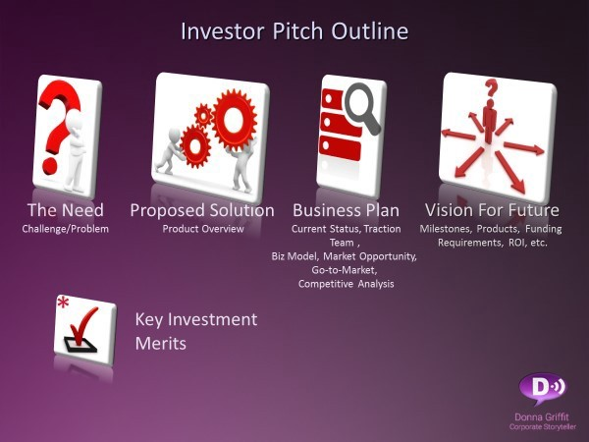
The High Level Outline of an Investor Pitch
The Need=The problem, the “villain” of the story
The Solution = The “hero” of the story, what will solve the problem and slay the villain?
The Business Plan— What will happen after the hero takes action?
Moving Forward— The aftermath, hoping that the hero is triumphant!
Drilling Down the Slides
Now I’ll go through slide by slide and explain each one.
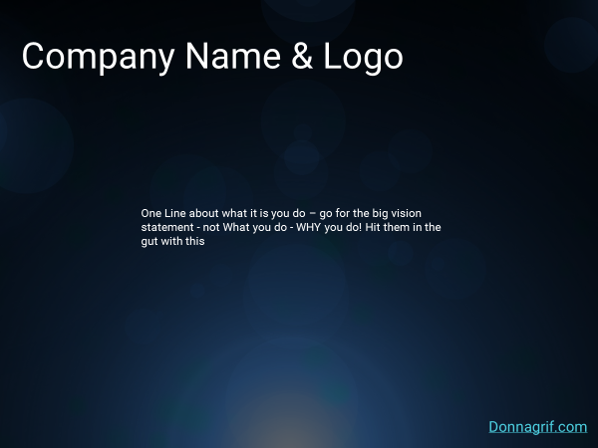
Title Slide— One Line about what it is you do — go for the big vision statement — not What you do — WHY you do! Hit them in the gut with this
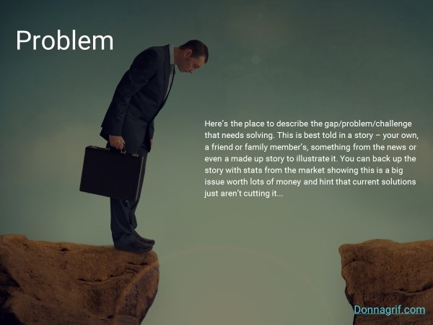
Problem- Here’s the place to describe the gap /problem /challenge that needs solving. This is best told in a story— your own, a friend or family members, something from the news or even a made up story to illustrate it. Back up the story with stats showing this is an issue worth lots of money and hint that current solutions aren’t cutting it…
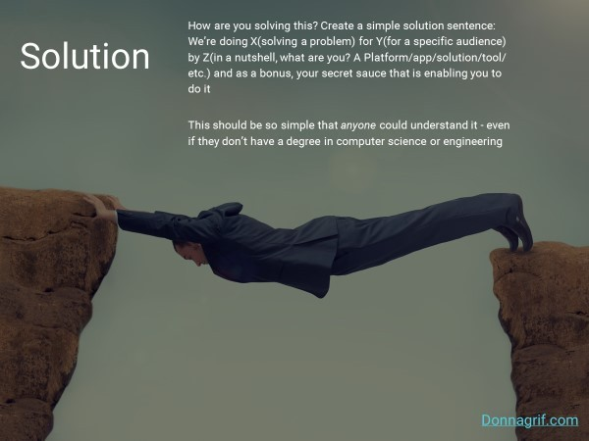
Solution— How are you solving this? Create a simple solution sentence: We’re doing X(solving a problem) for Y(for a specific audience) by Z(in a nutshell, what are you? A Platform /app /solution/tool/ etc.) and as a bonus, your secret sauce that is enabling you to do it This should be so simple that anyone could understand it — even if they don’t have a degree in computer science or engineering.
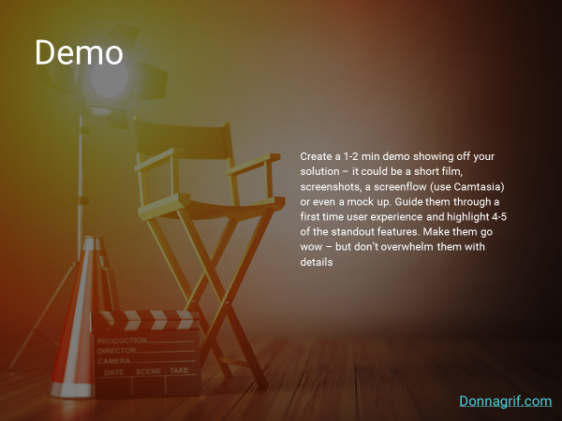
Demo—Create a 1–2 min demo showing off your solution — it could be a short film, screenshots, a screenflow (use Camtasia) or even a mock up. Guide them through a first time user experience and highlight 4–5 of the standout features. Make them go wow — but don’t overwhelm them with details.
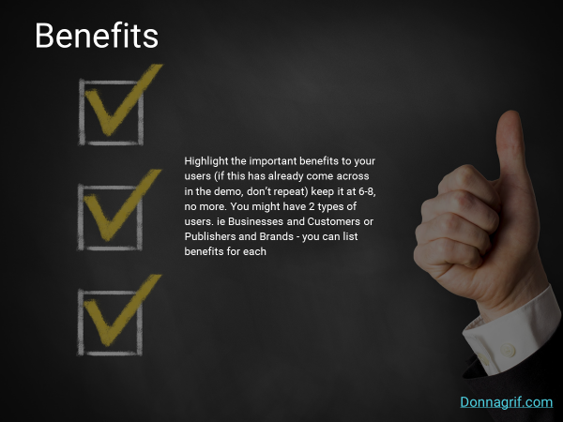
Benefits— Highlight the important benefits to your users (if this has already come across in the demo, don’t repeat) keep it at 6–8, no more. You might have 2 types of users. ie Businesses and Customers or Publishers and Brands — you can list benefits for each.
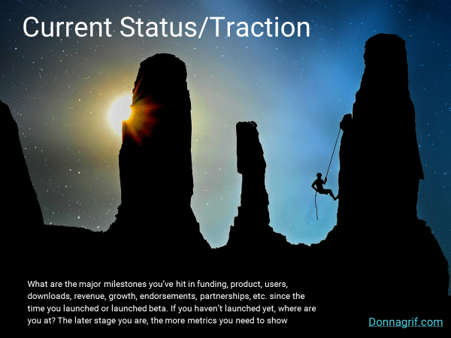
Current Status/Traction— What are the major milestones you’ve hit in funding, product, users, downloads, revenue, growth, endorsements, partnerships, etc. since the time you launched or launched beta. If you haven’t launched yet, where are you at? The later stage you are, the more metrics you need to show

Market Analysis— The numbers of the TAM (Total Addressable Market) SAM (Segmented Addressable Market) and SOM (Share of Market) so they get an idea of the size. Put value of the markets as well — what was the spend on similar solutions last year? You can go top down or bottom up — the most important thing to show is that you have a huge potential market!

Trends and Opportunities— This slide is a silver bullet! It’s the “Why us, why now?” This is the place to really show movement in trends and opportunities — have there been major fundings or acquisitions among your competitors? Did an industry leader or a research firm like Gartner, Forrester or the likes say that a solution like yours is missing? Are there market trends among your users showing a shift in behavior? Was there a change in law or regulations mandating people or companies to find a solution like yours? Etc.

Business Model— What is your main revenue model? (subscription, ads, affiliate, rev share, etc.) What are some additional revenue streams?

Go-to-Market Strategies —What are the strategies that will help you penetrate the market and gain users? Remember, you might not have money at the beginning for things like a sales team, so look at different phases — likely you will start with strategic partnerships, distribution channels or before that, content marketing or social campaigns.
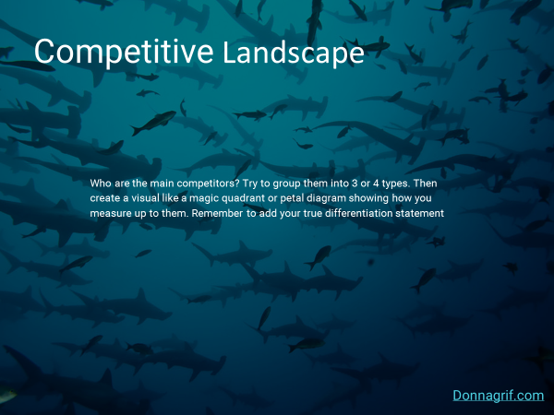
Competitive Landscape— Who are your main competitors? We’re talking either Enterprise, backed by VC money or rapidly growing companies — though you should know about smaller competitors as well. Try to group them into 3 or 4 types and then create a magic quadrant, a petal diagram or a marketscape showing how you measure up to them. Most important — add in your true differation statement: “What truly sets us apart is…” It’s very important to NOT say anything bad about your competitor — it’s GREAT that you have competition — now just prove that you have a clear advantage over them.

Team —Who are your Executive team members? Pics, titles and a few important facts about them. You can add logos of outstanding organizations they’ve worked for, been affiliated with or studied at. If you have an Advisory Board, add them too — it might need a separate slide.
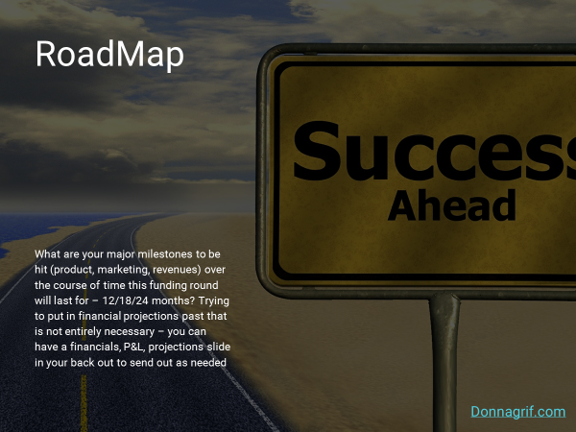
RoadMap —What are your major milestones to be hit (product, marketing, revenues) over the course of time this funding round will last for — 12/18/24 months? Trying to put in financial projections past that is not entirely necessary — you can have a financials, P&L, projections slide in your back out to send out as needed

Future Directions— Any exciting additional features or products in the pipeline that you intend to work on later? Maybe this is just the first step in a much bigger vision!
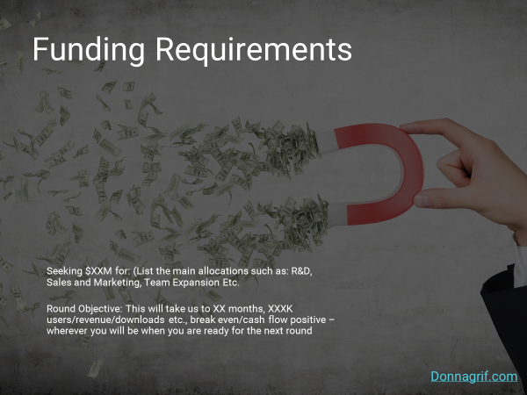
Funding Requirements —Seeking $XXM for: (List the main allocations such as: R&D, Sales and Marketing, Team Expansion Etc. Round Objective: This will take us to XX months, XXXK users/revenue/downloads etc., break even/cash flow positive — wherever you will be when you are ready for the next round.
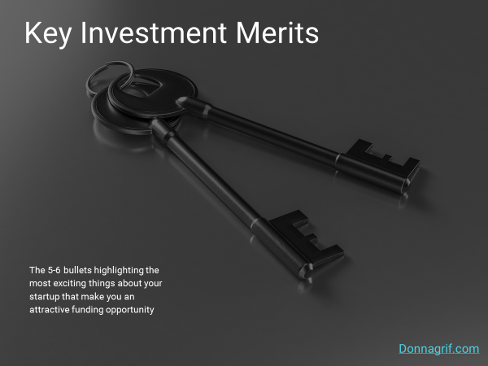
Key Investment Merits— Sort of a summary of what you’ve already said — the 5–6 bullets highlighting the most exciting things about your startup that make you an attractive funding opportunity.
Does Size Matter?
There is no magic number for slides! As long as they are simple, communicate one big idea and aren’t loaded with text, they aren’t going to count the slides as you go through. So even if you need to spread some of the data on to more than one slide, don’t sweat it — I’d rather see you have more simple, clear slides than fewer slides that look like eye charts!
Hope this was helpful! I’m here if you have any further questions or need any more support! And now — for the summary of all the slides:
If you enjoyed this article, please click the green heart below or share with a friend!

Donna Griffit is a Storyteller for Startups who, over 14 years, has helped hundreds of startups and VC’s around the world raise hundreds of millions of dollars. Need a pitch deck? Click Here

Aus <https://medium.com/the-mission/the-ultimate-cheat-sheet-for-your-startups-investor-pitch-deck-602f7ac97ace>

